2 Methods For Loading Data Into A Table

(always replace *userid* or bhmcfarland in examples with your id)

1. Create your *userid*_db database and then make it the active database.

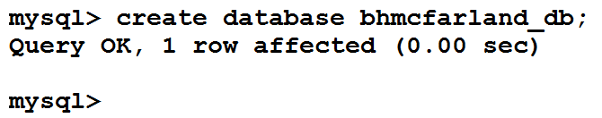



1. Check to see if you have a table named products_*userid****,*** where *userid* is your MySQL userid.

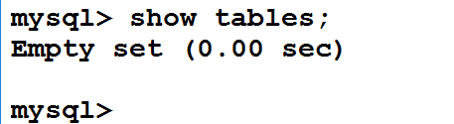

1. Using an editor of your choice (i.e. notepad++), create a batch sql file called create_products_table.sql If you save it as a .sql file first, then keywords will show in color.

This will drop the existing table if there is one and create a new empty table.

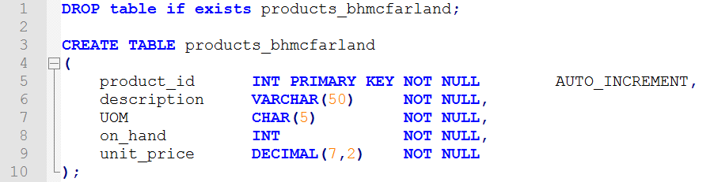

1. Use FileZilla (or some other method of your choosing) to move the file to your home directory on the server. Remember, when you connect to the server you are automatically in your home directory.
2. Execute the file by using the source command. You do not have to “path” the name since you logged on to MySQL from your home directory, then it is automatically pointing there.

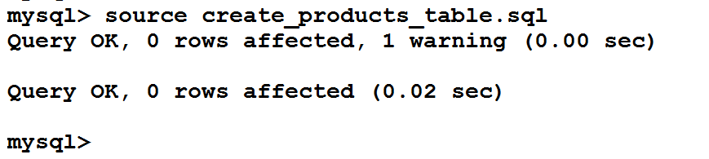

1. Verify that the table is there and that it is empty.

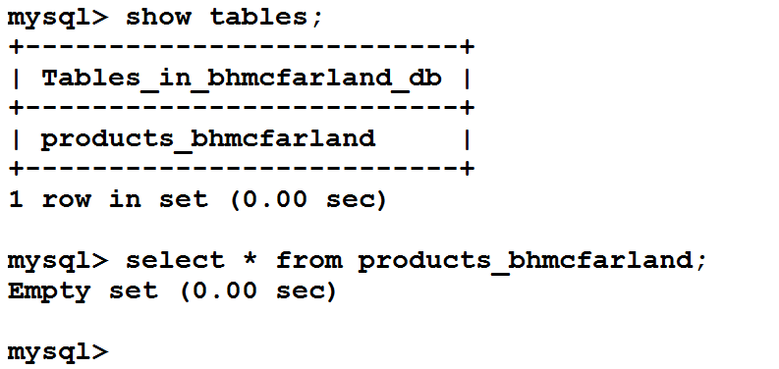

1. Now let’s create some data to put into the table ….. create a new file in your editor (notepad++) called populate_products_table.sql

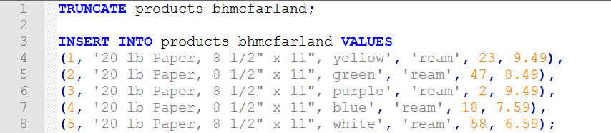

1. Use FileZilla (or some other method of your choosing) to move the file to your home directory on the server.
2. Execute the file by using the source command. This will insert the 5 rows in your file into the table you created in step 5 (producat_*userid*).

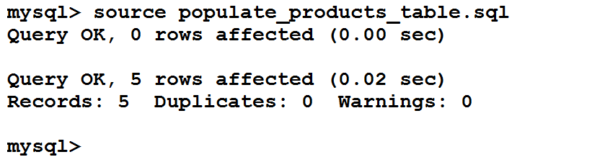

1. Verify that the table is populated now.

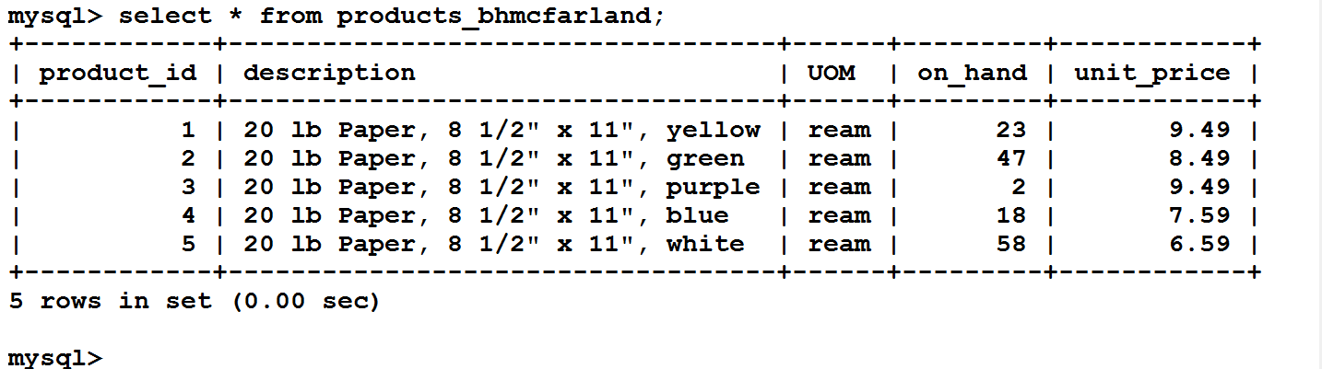

1. Truncate the data from the products_*userid* table and then verify that it is an empty table.

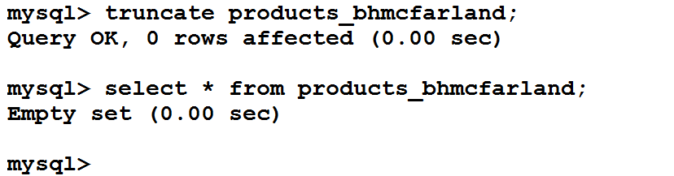

1. Now let’s create some data to put into table using the command line ….. create a new file in your editor called products.txt. Use a single tab between fields and enter at the end of the row. Do not leave a blank row(s) at the end.

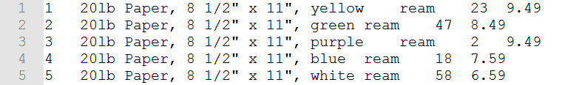

1. Use FileZilla (or method of your choosing) to move the file to your home directory on the server.
2. Now let’s load the data from this txt file into the products_*userid* table.

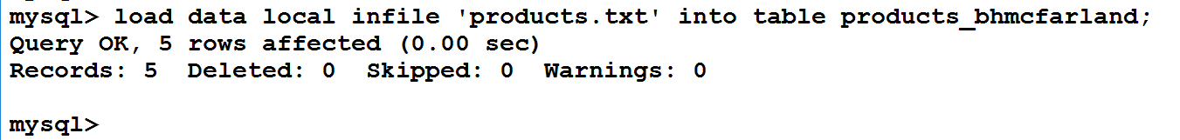

Verify that your data is loaded:

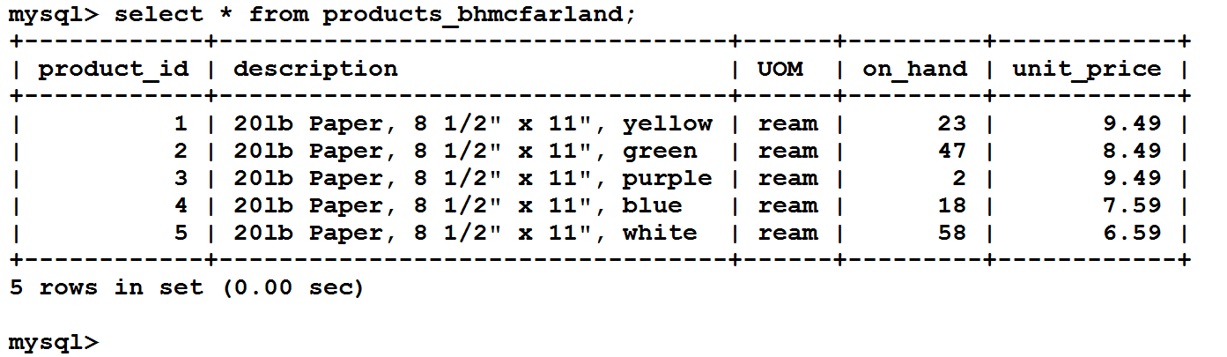

1. Since this was an in-class exercise, there is nothing to turn in. If you were present and privy to the information and had opportunity to ask questions, you will receive the grade.